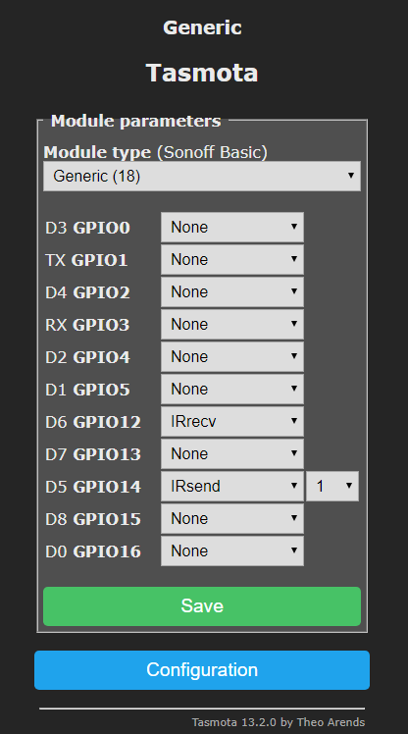

{"NAME":"IR","GPIO":[1,1,1,1,1,1,0,0,1088,1,1056,1,1,1],"FLAG":0,"BASE":18}

IRSEND {"Protocol":"NEC","Bits":32,"Data":"0x202B24D","DataLSB":"0x40404DB2","Repeat":1}

See also [SetOption29](https://tasmota.github.io/docs/Commands/#setoption29) - Set IR received data format

0 = Hex data (Default)

1 = Decimal data  
[SetOption38](https://tasmota.github.io/docs/Commands/#setoption38) - Set IR received protocol sensitivity

6 = Default sensitivity  
[SetOption58](https://tasmota.github.io/docs/Commands/#setoption58) - [IR Raw data in JSON payload](https://github.com/arendst/Tasmota/issues/2116#issuecomment-440716483)

0 = Raw data Turned Off (Default)

1 = Raw data Turned On